**Project2 Analysis Report**

* Xiaowei Wan

1. Scatter plot Age VS G1

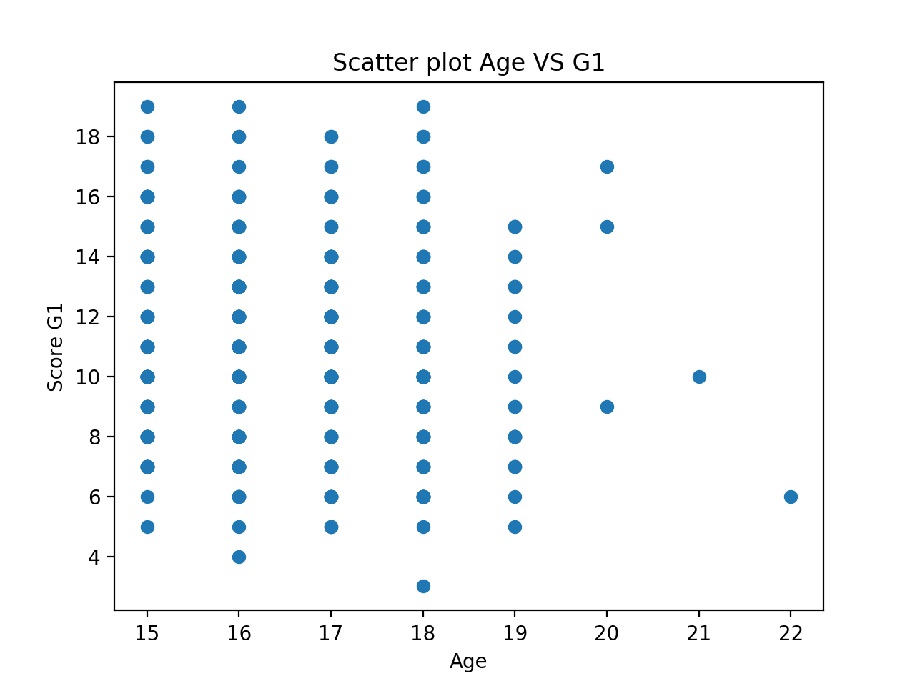

From above age vs G1 scatter plot, there is no strong relation between age and G1, likely the older you become, the less score you get. We can find that when you turn into 21 or older, you get less score, when 21, has 10, and 22 only has 6. Scores kind evenly distributed among students between 15 to 19 years old.

We can learn that younger students likely get higher score than older students.

1. Scatter plot of health VS G1  
   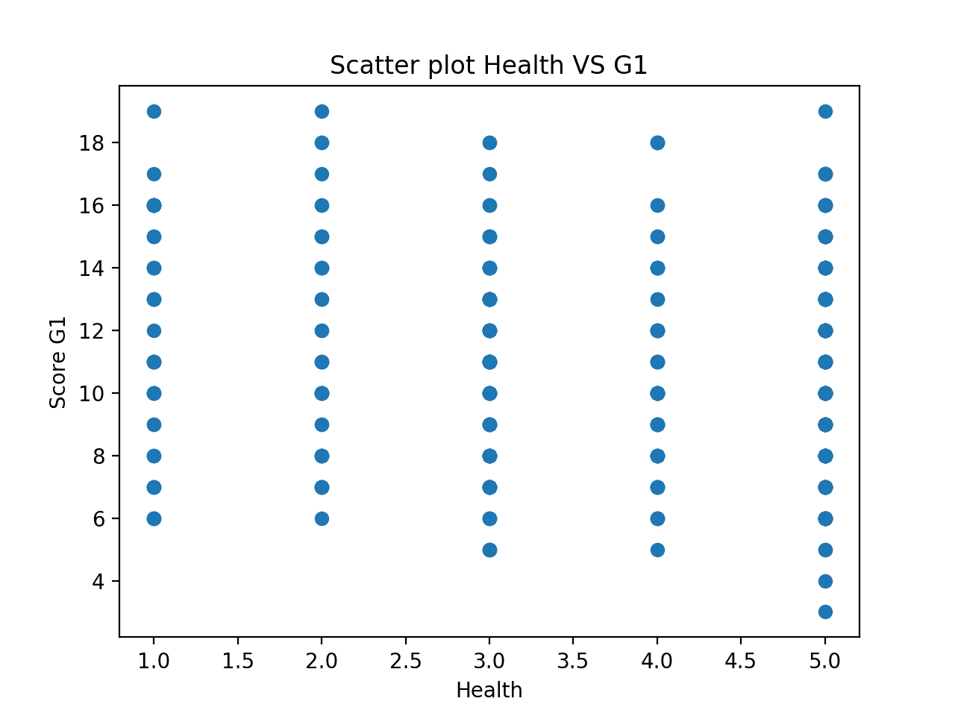  
   From above Health Vs G1 scatter plot, we can discover that when health condition is bad, like student didn’t get very low score, when health is very bad (1, 2), no students get score 4 or 5. And when students in very good health (5), some student get very low score 4 or less. Students health has no strong relation with Score G1. Evenly distributed between all kind health condition.

1. Scatter plot of freetime VS G1

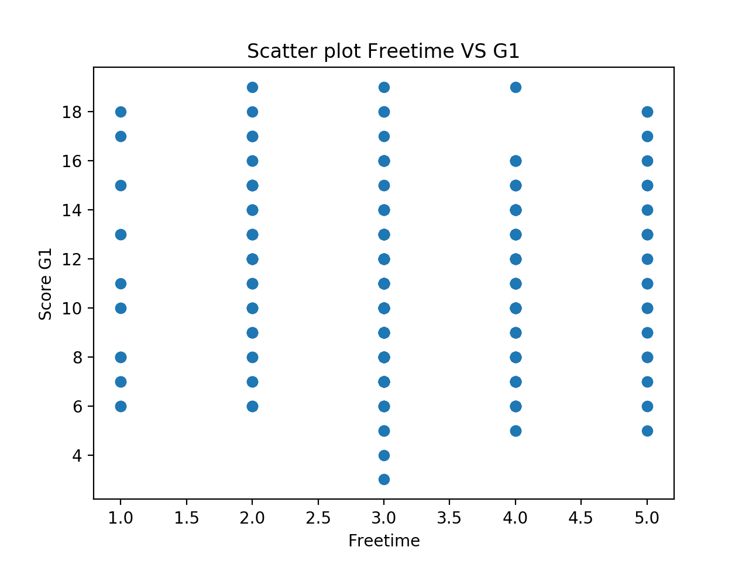

From above scatter between freetime and G1, we can get that when students who have less free time after school, don’t get higher score 6 or more. And students who have more free time after school, likely can get lower score, such 5 or less. And from above graph, we can say that students who have 3 hours free time after school get lowest score 3 or less. And also get the highest score 20 or more. Students have only 1 hour free time after school didn’t get highest score. On the contrary, some students who have 4 hours free time after school get more than 18 scores. So there is no strong relation between free time after school and score G1 among students.